Century Electronics Store

Project Report

Class: t2208a

Semester: 2

Group 5:

Nguyễn Trọng DŨng

2023

Table of contents

------

1. Problem Definition
   1. Introduction
   2. Implementation Environment
2. User Story
   1. Customer
   2. Admin
3. System Analysis
   1. User Flow
   2. Database Design
   3. Tech Stack
4. UI/UX
   1. Home
   2. Category
   3. Product Details
   4. Cart
   5. Checkout
   6. Completion
   7. Order Tracking
   8. Sign in
   9. Sign up
5. **Problem Definition**
   1. Introduction

**Century Electronics Store** is an e-commerce website that is created to **help both customer and business owner during their commerce activities online,**

With 3 main product categories here are : **Laptop**, **Smartphone** and **Tablet**.

* 1. Implementation
* **XAMPP** – to run PHP
  + Change xampp apache **port** from 80 to **8888**

Listen 8888

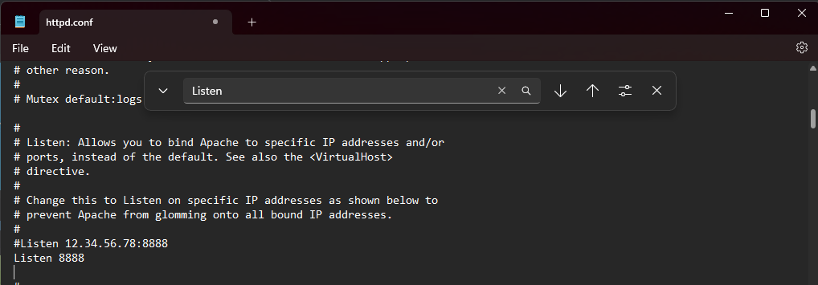

ServerName localhost:8888



Move **electronics-ecommerce-backend** folder to xampp **htdocs** folder in order to run PHP and server-side code.

* **Nodejs** – to run React
  + In terminal,

cd to **electronics-ecommerce-frontend**

run ‘**npm** **install**’ to install all dependencies

then run ‘**npm start’** to start

* **MySQL (with XAMPP)**
  + Create a database ‘**electronics-ecommerce’**
  + Import ‘ electronics_ecommerce.sql ’
* Install Composer (if needed, to use PHPMailer and JWT)
* Run ‘ **xampp-control.exe** ‘ as an Administrator to have permission to create image folder in PHP.
  + Properties -> Compatibility
  + -> Change settings for all users
  + -> Run as an administrator

1. **User Story**
   1. Customer

* Account
  + Sign in / Sign up
  + Profile
  + My Orders
* View products
  + by category
  + with filter
* Shopping process
  + Cart
  + Checkout
  + Completion (if checkout success)
* Order Tracking
  + Inside Account -> My Orders
  + With phone number (for guest)
  1. Admin
* Category
  + Manage products
    - Laptop / Tablet / Smartphone CRUD
    - Brand CRUD
  + Manage customers
    - View basic info
  + Manage orders
    - View order info

1. **System Analysis**
   1. User Flow

Customer User Flow

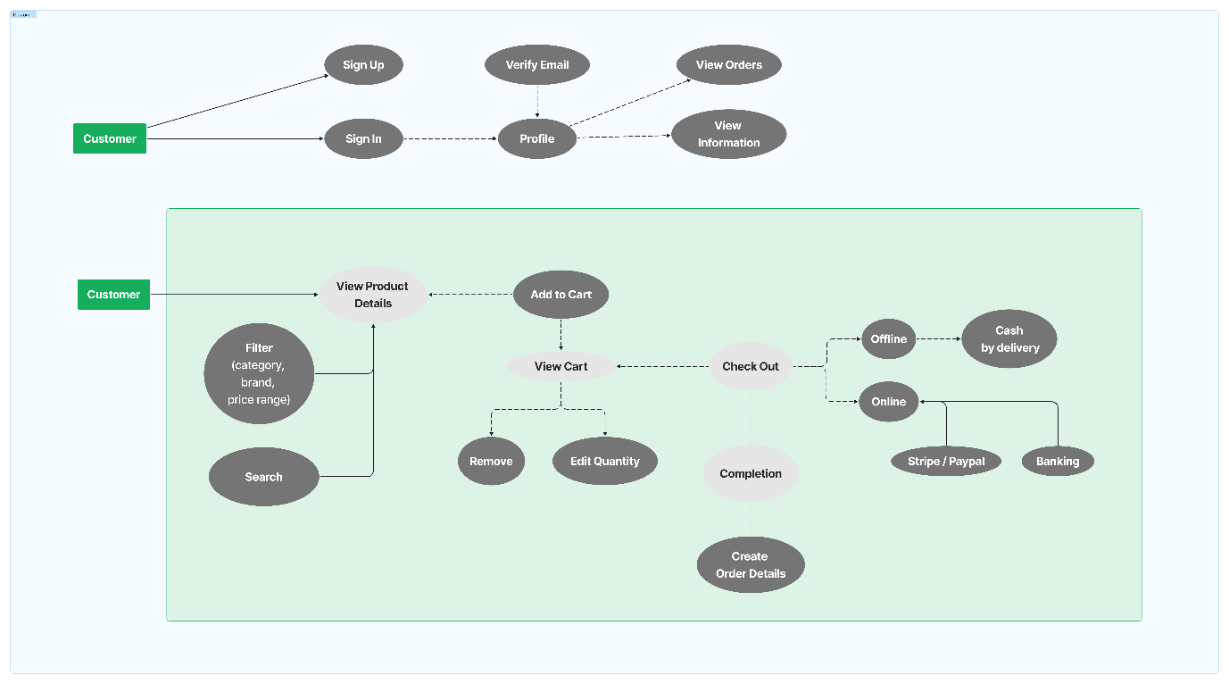

Admin User Flow 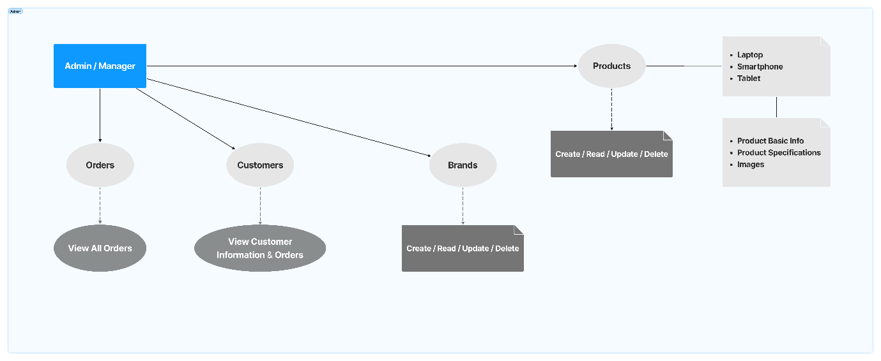

Customer uSe cAsE

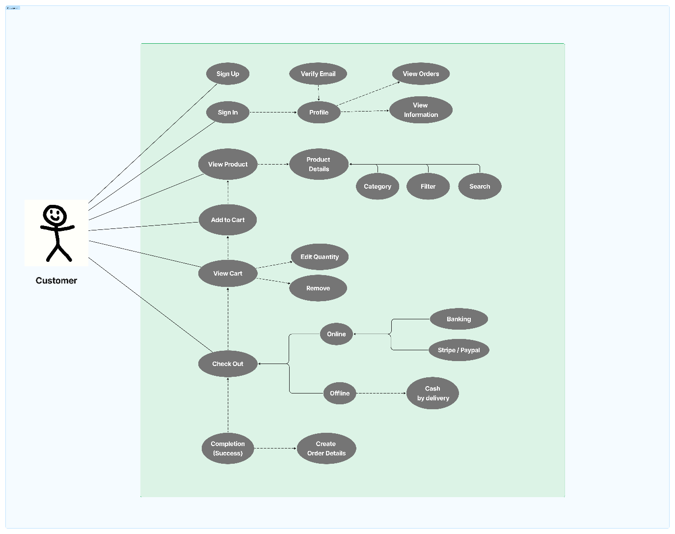

* 1. Database design

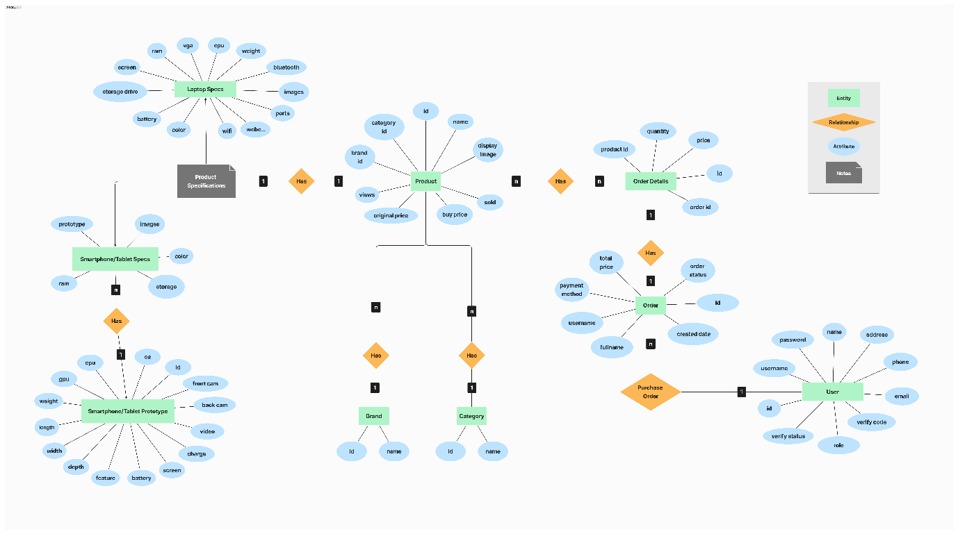

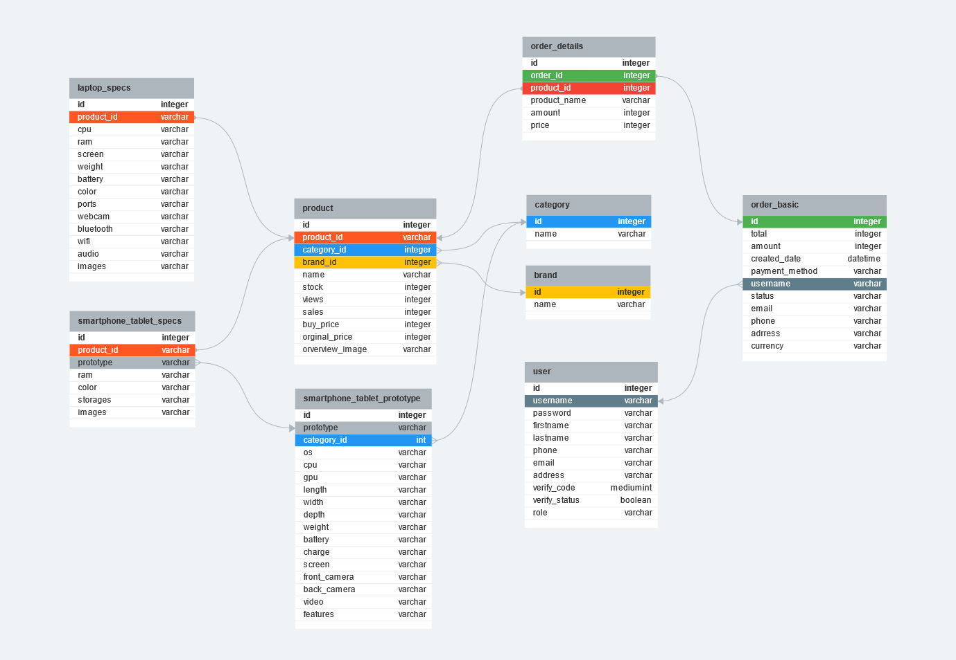

1. **UI/UX**

* **Home**

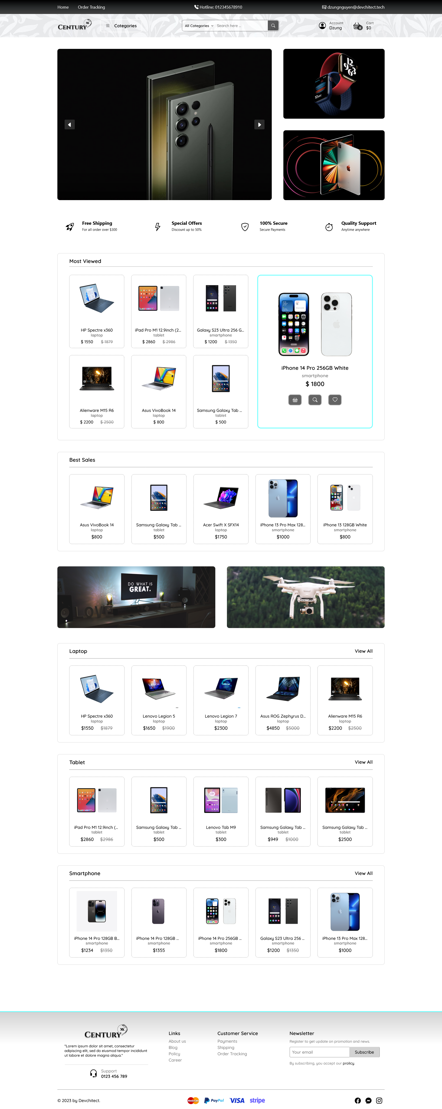

* **Category**

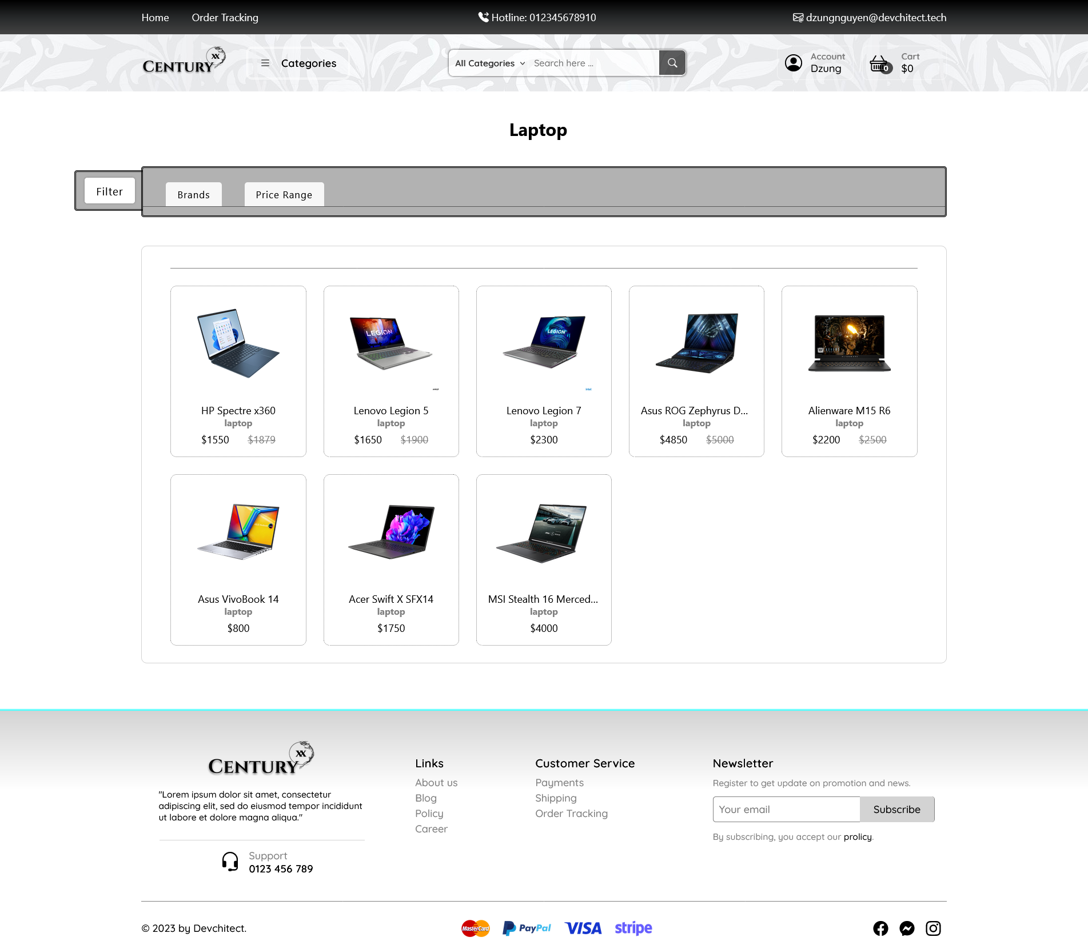

* **Sign In**

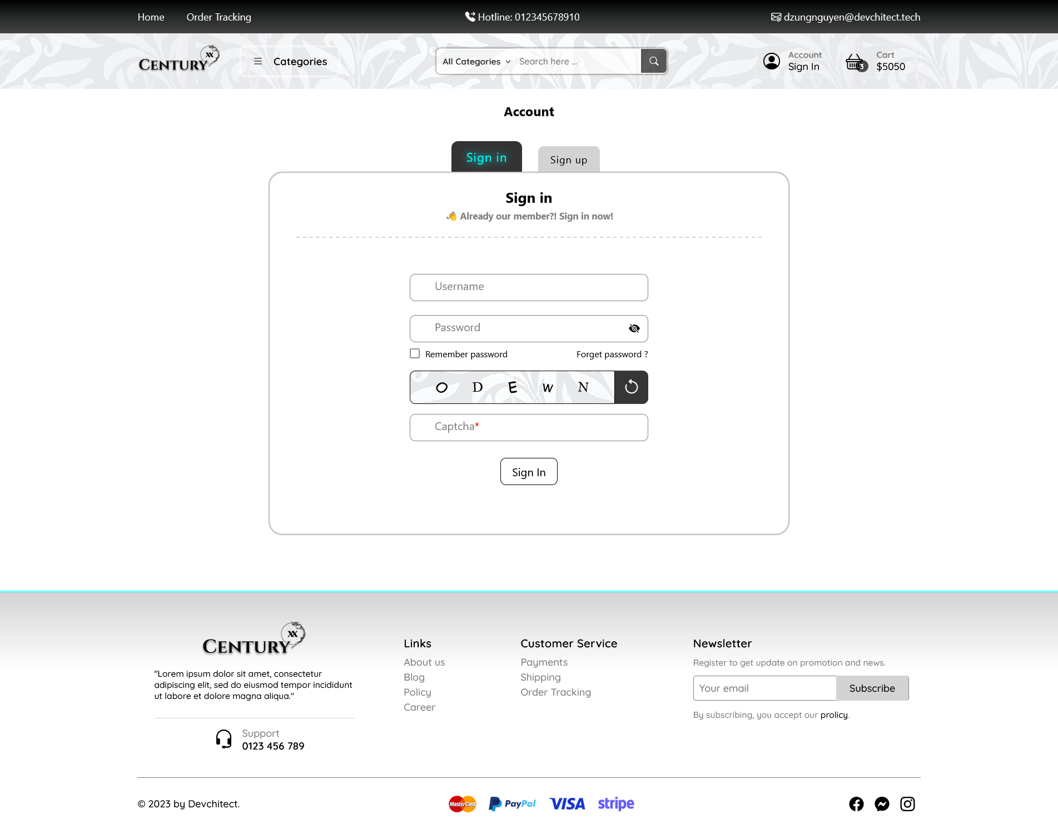

* **Sign Up**

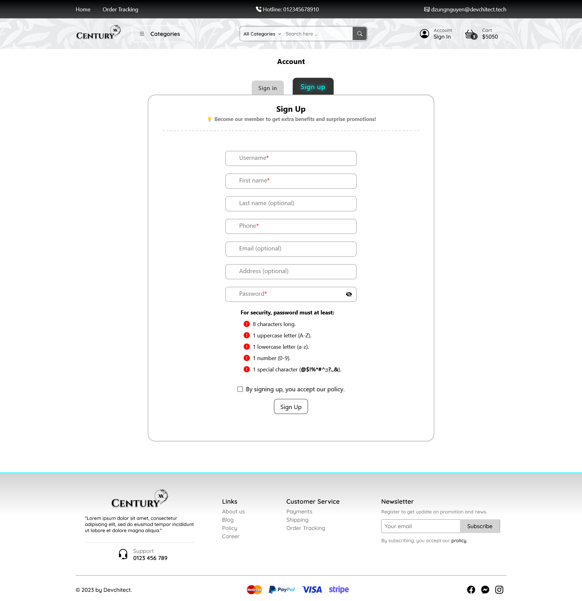

* **Cart**

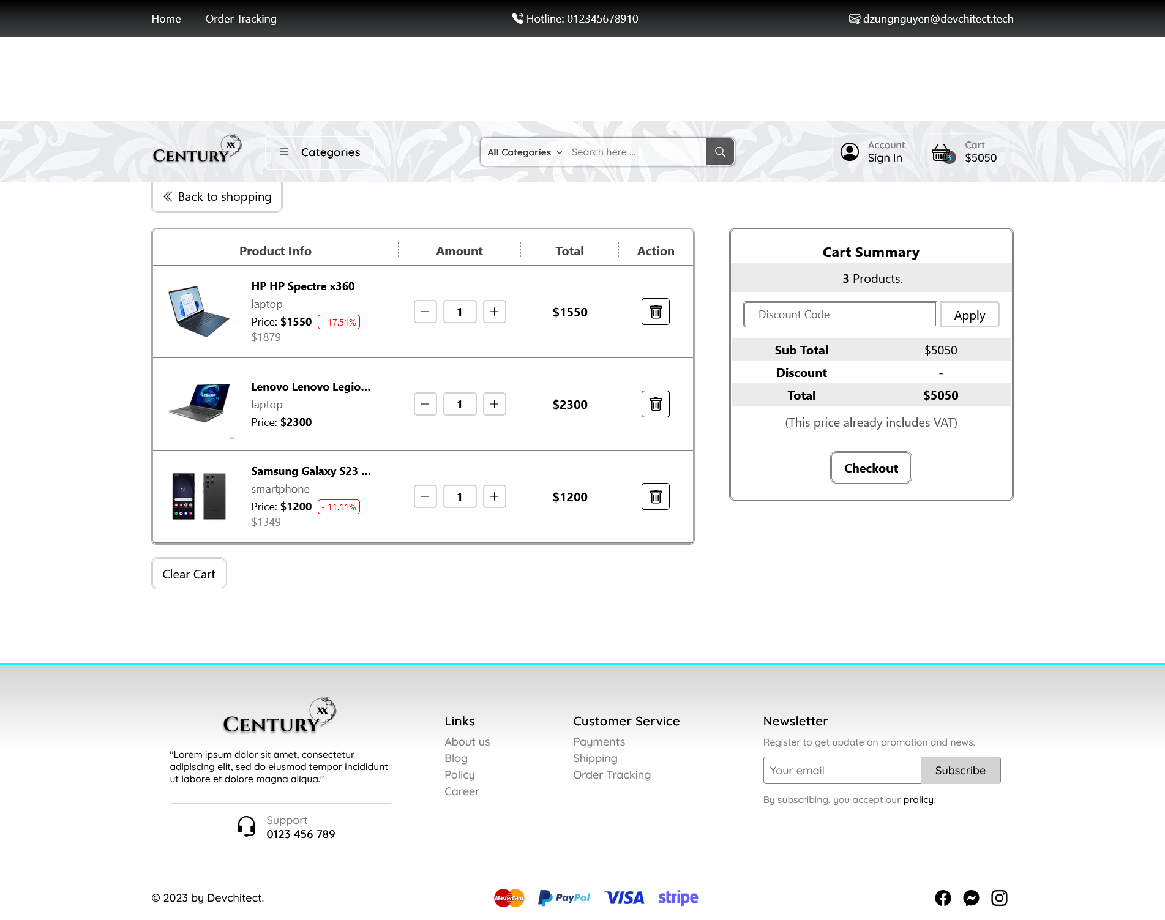

1. **Checkout**

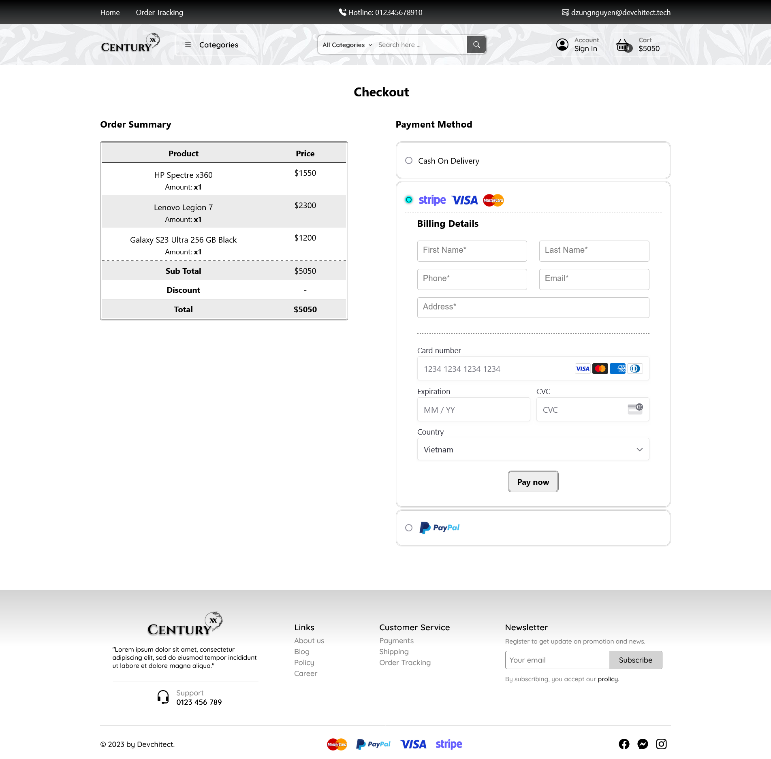

1. **Completion**

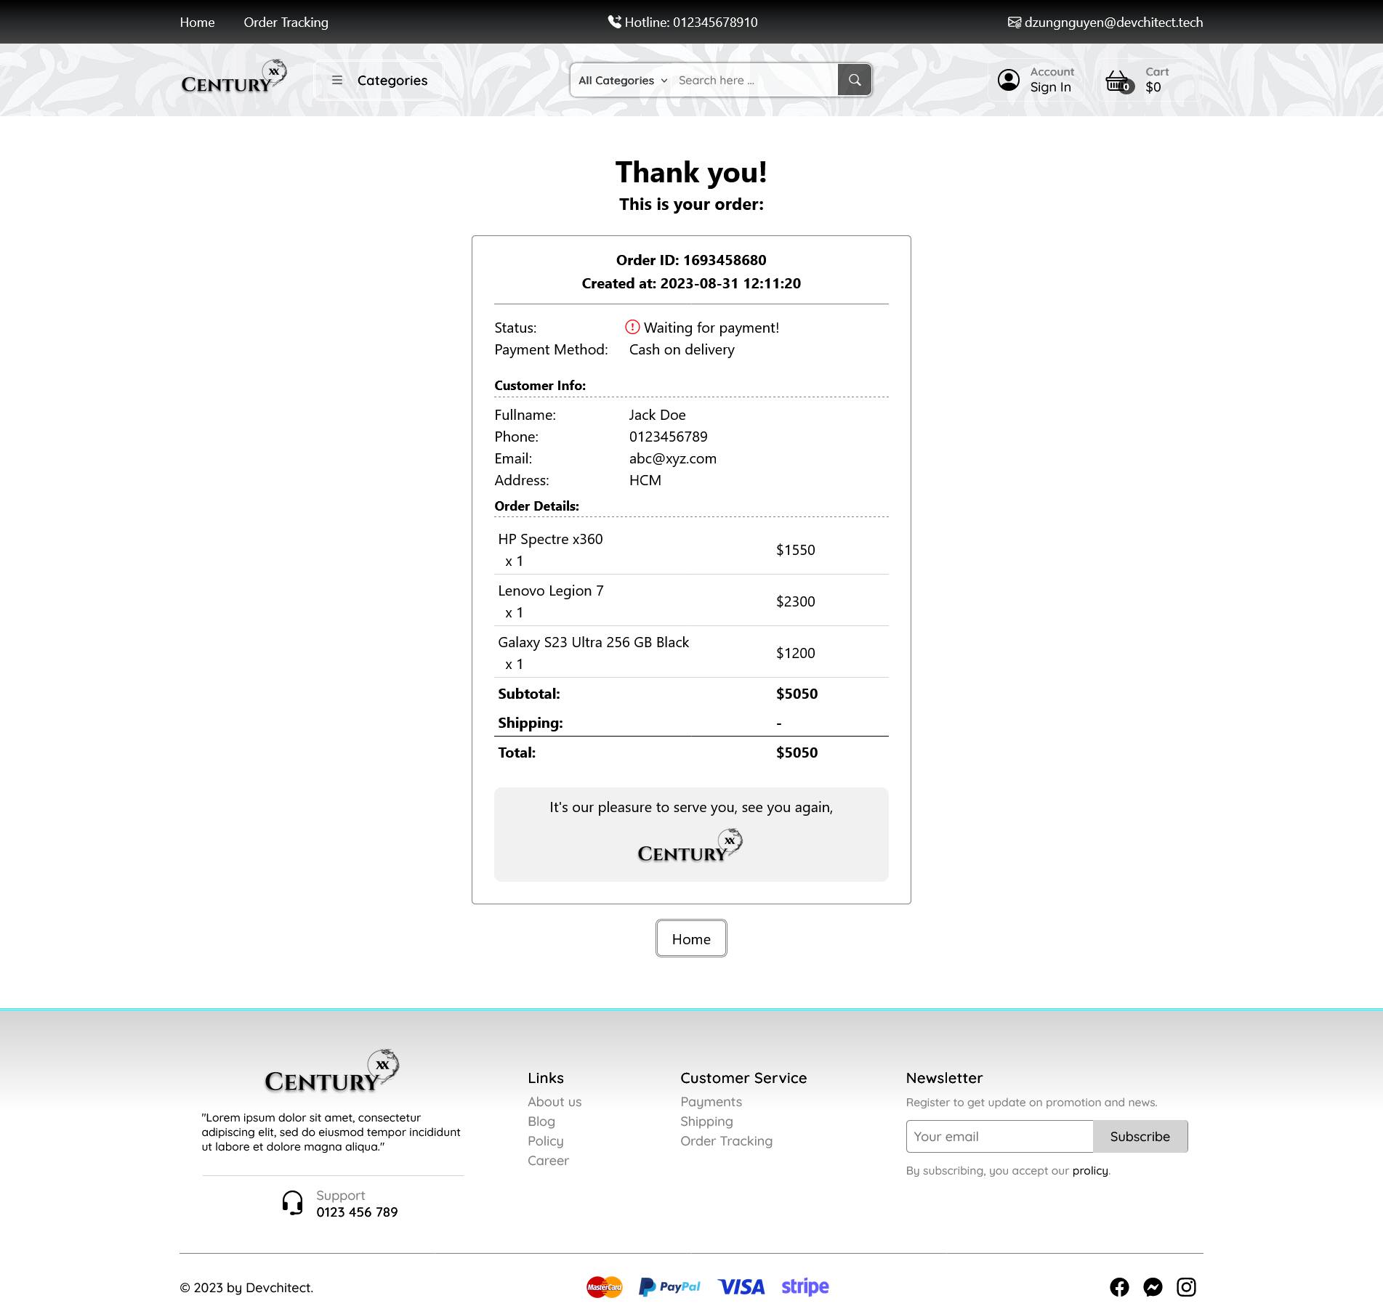

1. **Order Tracking**

